**Assignment - 4**

|  |  |
| --- | --- |
| Assignment Date | 16/11/2022 |
| Student Name | K.Venkatesh |
| Student Roll Number | 212219060141 |

**Question:**

Write code and connections in WokWi for Ultrasonic Sensor. Whenever the distance is less 100cm, send “Alert” to IBM cloud and display in device recent events.

**Solution:**

**Circuit Diagram:**

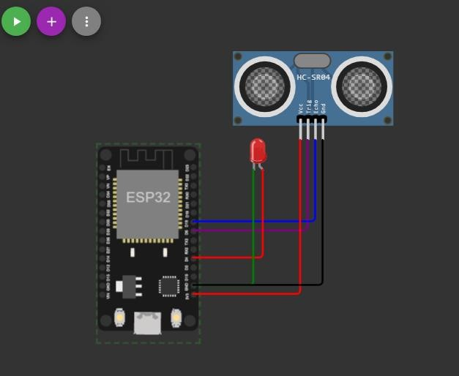

**Code:**

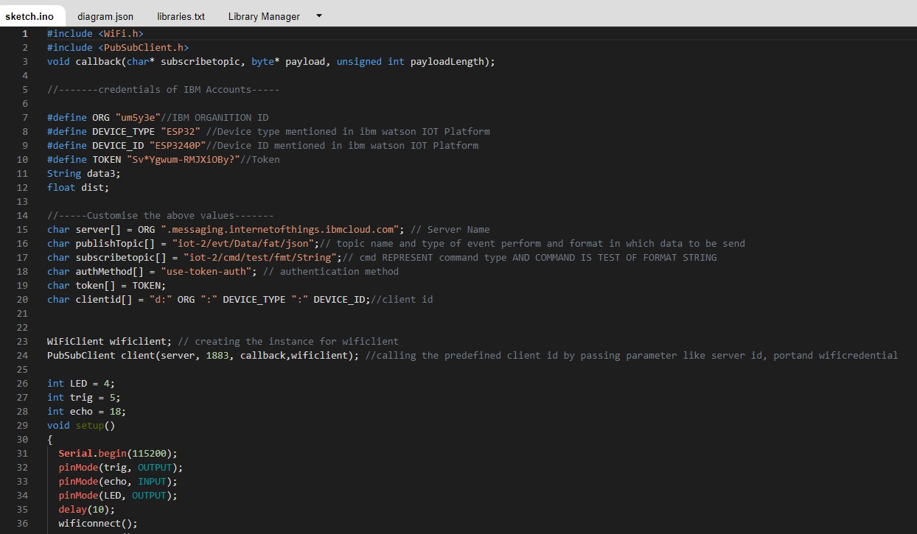

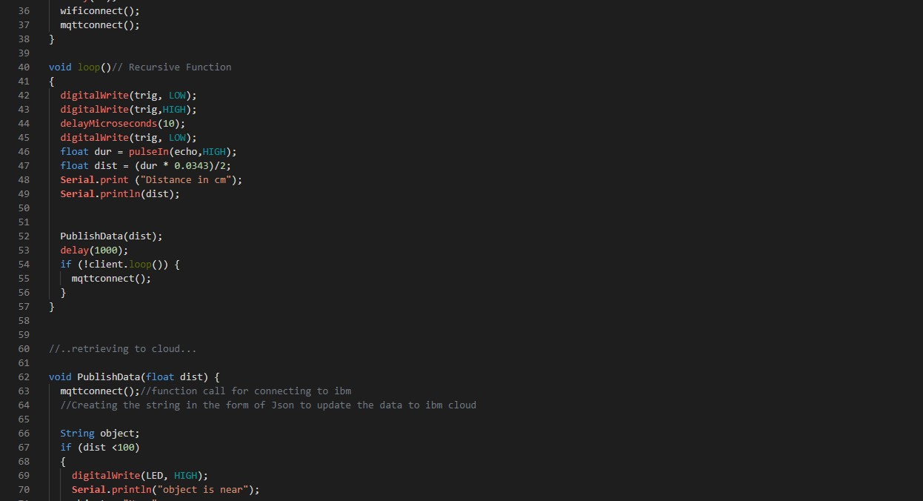

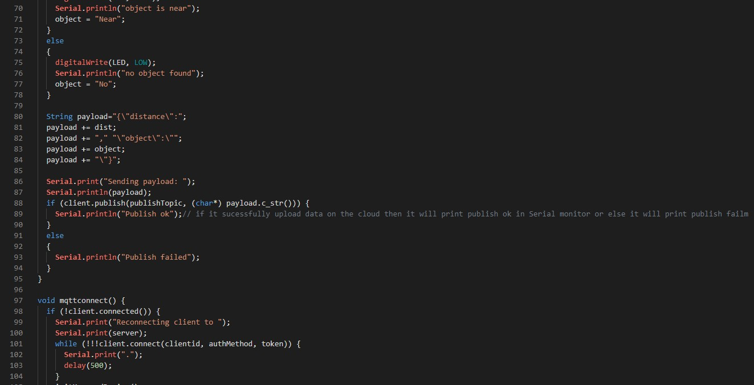

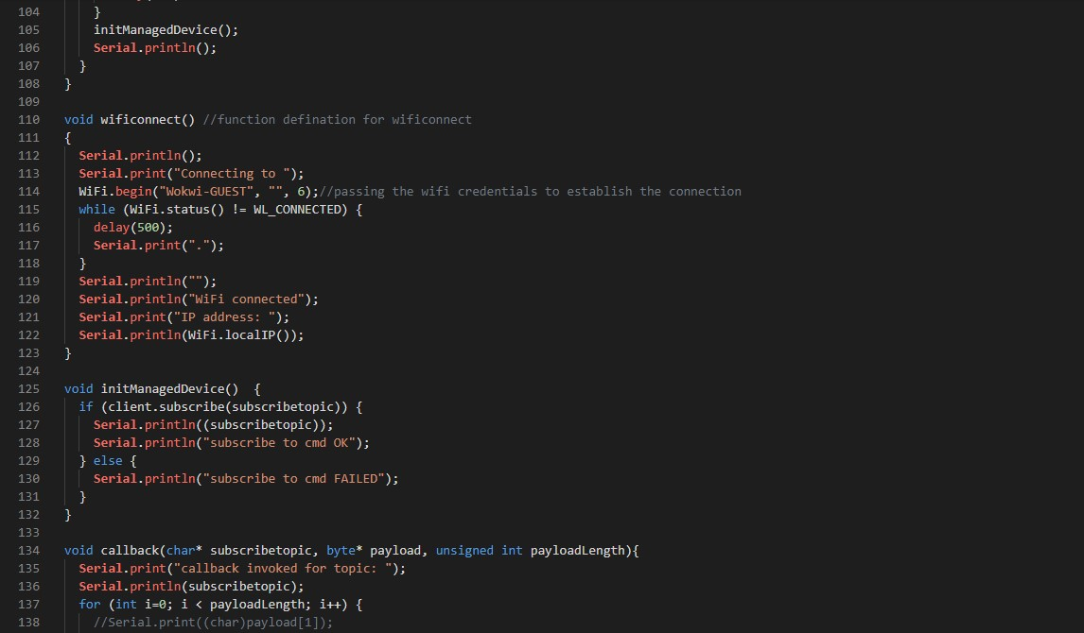

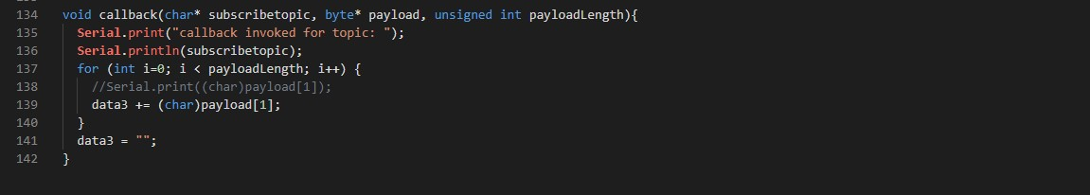

**OUTPUT:**

**When the Object is Far:**

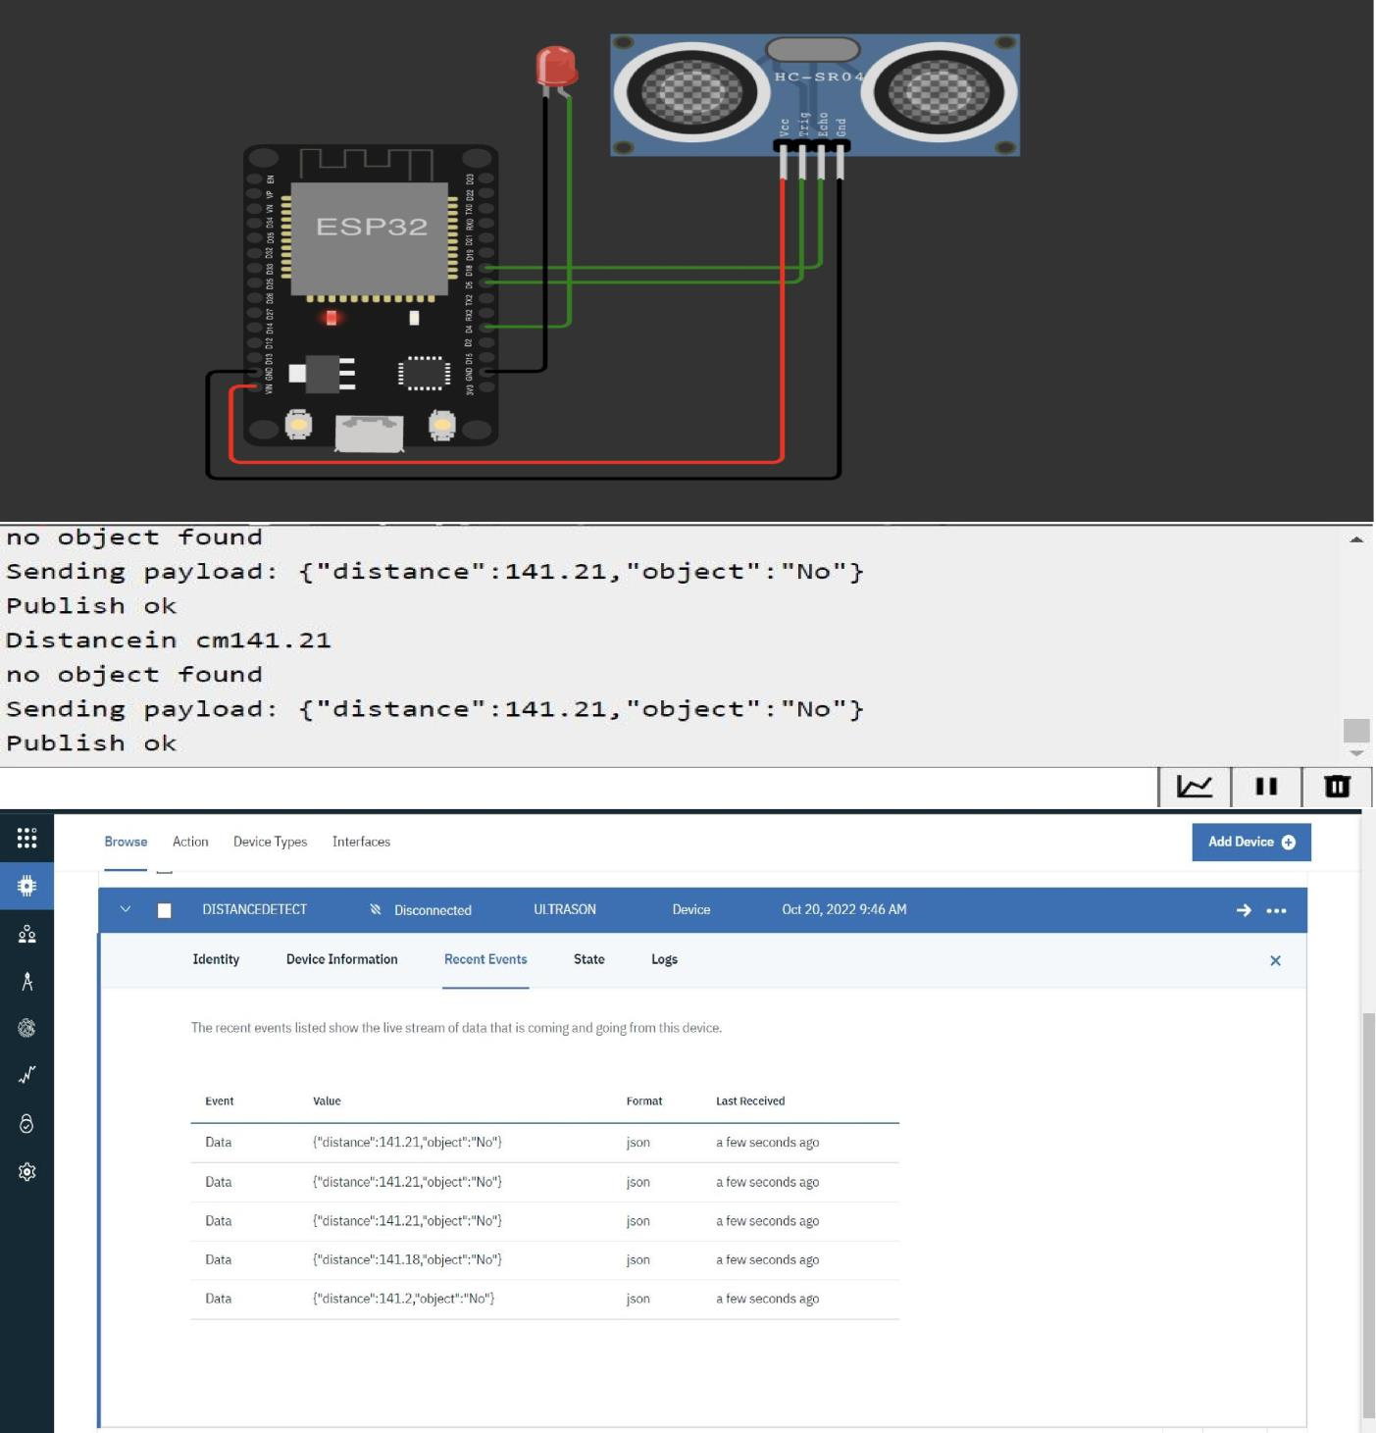

**When the Object is Near:**

